Ind AS, IFRS and US GAAP Reporting

1. Hero section
H1: Ind AS, IFRS and US GAAP Reporting That Stands Up to Audit, Investor and Transaction Scrutiny
Sub-heading (lead paragraph): Reporting under Ind AS, IFRS and US GAAP is where accounting judgement, disclosure quality and the audit trail all meet. When conclusions are unclear, workings are weak or deadlines are tight, financial information stops being reliable. Contetra provides Ind AS, IFRS and US GAAP reporting services helps finance teams reach defensible positions, prepare the underlying calculations and produce audit-ready financial statements under each of these frameworks.
Supporting paragraph: We support recurring reporting as well as one-off complex matters. Our Ind AS reporting services spans standard interpretation, accounting policy papers, financial statement preparation, consolidation, disclosures and audit support under Ind AS, IFRS and US GAAP. For Indian reporting entities this extends to Schedule III presentation and disclosure, CARO 2020 reporting matters, related-party disclosure under Section 188, and support for the internal financial controls opinion under Section 143(3)(i). We work as an extension of your finance team, not as a distant adviser.
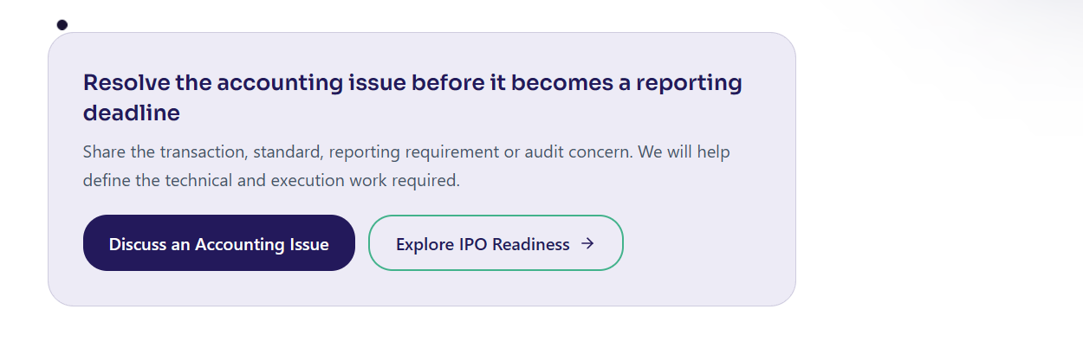
Kicker line above buttons: Share the transaction, standard, reporting requirement or audit concern. We will help define the technical and execution work required.
Primary button: Discuss an Accounting Issue Links to: /contact-us form pop-up
Secondary button: Request an Audit-Readiness Review Links to: /contact-us

2. Customers we work with (client logos)
Section label: Trusted by finance and business leaders


3. What challenges are being faced (target audience pain points)
Section heading: Where Ind AS, IFRS and US GAAP reporting usually goes wrong (H2)
Intro line: Most finance teams do not lack accounting knowledge. They lack the time, the specialist depth or the documented workings to make complex positions withstand scrutiny. If any of these sound familiar, this is where we help.
Card 1 - Complex judgements are unresolved or undocumented Revenue, leases, financial instruments, business combinations, consolidation or share-based payments require a defensible conclusion, and the supporting rationale does not yet exist.
Card 2 - Disclosures do not keep pace with the standards Schedule III, note disclosures and framework-specific requirements are incomplete or inconsistent, which raises audit queries and delays sign-off.
Card 3 - The close depends on manual, uncontrolled workings Financial statements are prepared without a controlled, review-based process, so quality varies and reconciliations cannot always be traced back to source.
Card 4 - Ind AS, IFRS and US GAAP differences are not mapped Group reporting or a foreign parent needs numbers under more than one framework, and the differences between them have not been identified, quantified or documented.
Card 5 - Audit queries arrive without ready evidence Year-end audit raises questions on complex judgements for which there is no memo, no calculation file and no clear standard reference.
Card 6 - Internal capacity cannot absorb the technical peak A transaction, a new standard, a reporting conversion or an audit peak exceeds what the internal team can deliver alongside day-to-day operations.
(Keep headings in the image as h3)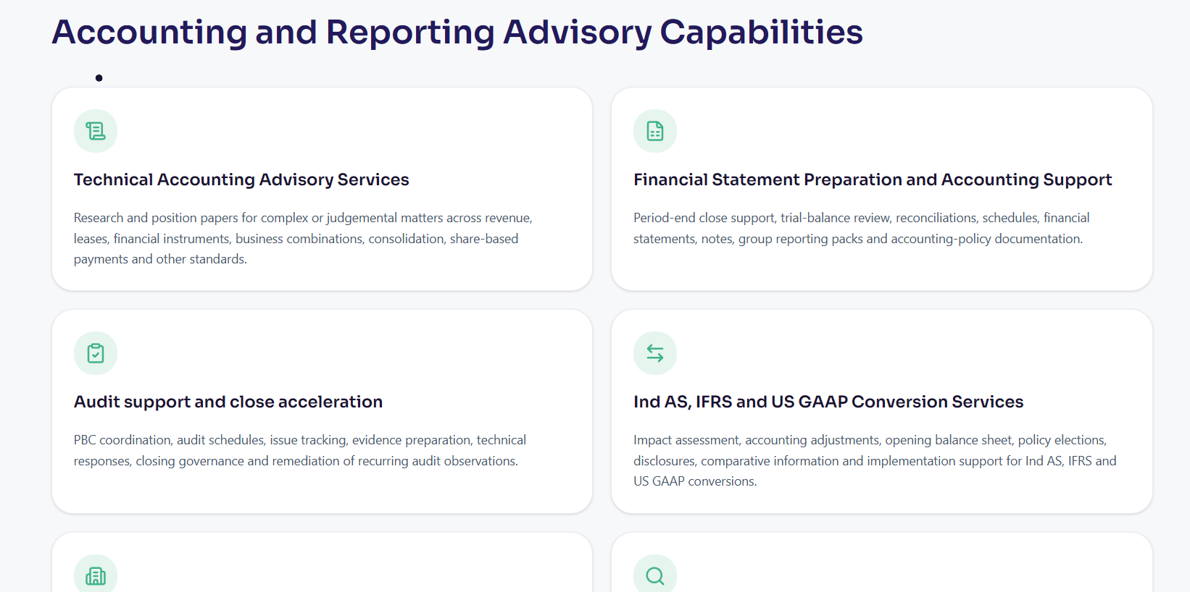
4. What solutions do we offer
Section heading: How Contetra supports Ind AS, IFRS and US GAAP reporting (H2)
Intro line: We combine standards knowledge with practical delivery. That means we do not stop at the accounting memo. We help you implement the conclusion in the books, the financial statements and the audit file.
Solution 1 - Technical accounting advisory Research and position papers for complex or judgemental matters across revenue, leases, financial instruments, business combinations, consolidation, share-based payments and other standards, under Ind AS, IFRS and US GAAP.
Solution 2 - Our IFRS reporting services can include trial-balance review, reconciliations, schedules, primary statements, notes, accounting policies and group reporting packs, prepared to be audit-ready and fully documented.
Solution 3 - Disclosures and Schedule III compliance Note disclosures, transition reconciliations, related-party and framework-specific requirements, and Schedule III presentation for Indian reporting entities.
Solution 4 - Consolidation and group reporting Control assessments, eliminations, non-controlling interests, foreign operations and consolidation adjustments, aligned to group timelines and standards.
Solution 5 - Our US GAAP reporting services can support businesses with impact assessment, policy design, opening adjustments and transition support when a new standard applies or when the same numbers are needed under more than one of Ind AS, IFRS and US GAAP.
Solution 6 - Audit support and close acceleration PBC coordination, audit schedules, evidence preparation, technical responses to auditor queries and remediation of recurring observations, so sign-off is faster and cleaner.
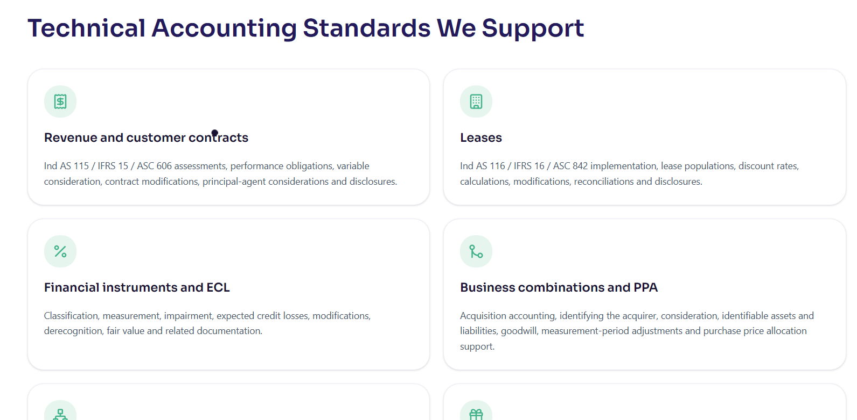
5. Our existing offered solutions (case studies)
Section heading: Ind AS, IFRS and US GAAP reporting work we have delivered (H3)
Intro line: A selection of engagements from our accounting and reporting practice. Explore the full set on our case studies page.
Practus Professional Services (Professional Services) Before (h4): the company was transitioning to Ind AS and needed technical guidance on first-time adoption choices. Solution: Contetra advised on transition elections, computed the opening balance sheet adjustments and prepared the disclosures. After: the Ind AS transition was completed, with first-time adoption adjustments processed and disclosed correctly.
BOB Financial Solutions (Financial Services and NBFC) Before (h4): RBI and Ind AS 109 required a robust ECL model that the internal team lacked the expertise to build. Solution: Contetra built the ECL computation model, covering stage classification, PD and LGD inputs and scenario weighting. After: the ECL model became operational, with provisioning compliant with Ind AS 109 and accepted by auditors without query.
Kotak Securities (Financial Services and NBFC) Before (h4): the finance team needed practical guidance on implementing a new accounting standard across the business. Solution: Contetra led the standard implementation, including impact assessment, policy design and transition adjustments. After: the new standard was implemented cleanly, with the policy documented, adjustments processed and auditors satisfied.
IMCD India (Manufacturing) Before (h4): the company was preparing financials in-house but lacked technical Ind AS expertise for complex disclosures.
Solution: Contetra managed the full financial statement cycle, from trial balance to final signed-off statements. After: audit-ready financials were delivered, with technical disclosures correctly applied and well documented.
Mastek (Diversified Group) Before (h4): consolidated financial statements were being delayed due to technical complexity and resource gaps.
Solution: Contetra managed the consolidation process, including eliminations, adjustments and disclosure preparation. After: consolidated statements were delivered on time, with complex accounting judgements documented and auditor-ready.
Bitonic Technology Labs (Pharma and Life Sciences) Before (h4): the business needed formal accounting policy papers to support IFRS-compliant financial reporting. Solution: Contetra prepared technical memos covering the applicable standards, policy choices and disclosure requirements. After: the technical memos were issued, IFRS compliance was documented and auditors were given clear supporting rationale.
Onemi Technology Solutions (Technology) Before (h4): the finance team lacked internal expertise to interpret and apply new IFRS standards to the business.
Solution: Contetra provided practical advisory on the standard, covering interpretation, policy design and implementation. After: the IFRS standard was applied correctly, with the policy documented and disclosure quality improved in the next reporting cycle. Ashapura Aromas (Manufacturing) Before (h4) : financial statements were being prepared manually without a controlled, review-based process.
Solution: Contetra took end-to-end ownership of financial statement preparation under Ind AS and IFRS. After: statutory financials were prepared on time and audit-ready, meeting technical quality and disclosure standards.
Section CTA link: Browse all case studies → /proof/case-studies

6. Insights and blogs (Compliance and International GAAP)
Section heading: Insights on Ind AS, IFRS and US GAAP reporting
Intro line: Practical thinking on complex standards, disclosures and audit-ready reporting under international frameworks.
Developer note: pull the latest posts from /blog filtered to the Compliance and International GAAP category, newest first, showing three to four cards. Do not hard-code titles, since the blog updates. Each card should show the post title, a short excerpt, the category tag and a "Read more" link to the post. Link the section heading to the blog filtered by Compliance and International GAAP.
Section CTA link: Read more insights → /blog

7. Frequently Asked Questions (minimum 10)
Section heading: Ind AS, IFRS and US GAAP Reporting FAQs
Q1. What is the difference between Ind AS, IFRS and US GAAP?
Ind AS is the set of Indian Accounting Standards, largely converged with IFRS and applied by many Indian companies. IFRS is the international framework issued by the IASB and used across much of the world. US GAAP is the United States framework issued by the FASB. The three overlap in many areas but differ in specific recognition, measurement, presentation and disclosure requirements, which is why reporting under each needs framework-specific judgement.
Q2. Which framework does my company need to report under?
It depends on your size, ownership, listing status, lenders and group structure. Listed and larger Indian companies typically report under Ind AS. Businesses with a foreign parent or foreign investors may also need IFRS or US GAAP numbers for group reporting. We help you confirm which frameworks apply and where more than one is required at the same time.
Q3. Can Contetra prepare complete financial statements under these frameworks? Yes. Depending on the engagement, support can include trial-balance review, reconciliations, schedules, primary statements, notes, accounting policies, cash-flow statements, group reporting packs and audit-ready supporting documentation under Ind AS, IFRS or US GAAP.
Q4. What is technical accounting advisory?
It is the work of interpreting and applying accounting standards to complex transactions or reporting matters, documenting the conclusion, and implementing the resulting entries, calculations and disclosures. It gives management and auditors a defensible, standard-referenced position rather than an undocumented judgement.
Q5. How do you handle complex standards such as revenue, leases and financial instruments?
We assess the specific facts against the applicable standard, for example Ind AS 115, IFRS 15 or ASC 606 for revenue, Ind AS 116, IFRS 16 or ASC 842 for leases, and Ind AS 109 or IFRS 9 for financial instruments and expected credit losses. We then document the position and prepare the calculations, entries and disclosures needed to apply it.
Q6. What is involved in Schedule III and disclosure compliance?
For Indian reporting entities, Schedule III sets out the format and disclosure requirements for financial statements. We help prepare compliant presentation and notes, including related-party disclosures under Section 188 and other framework-specific requirements, so the financial statements are complete and consistent.
Q7. Can you help with consolidation and group reporting?
Yes. We support control assessments, group structures, eliminations, non-controlling interests, foreign operations, reporting packs and consolidation adjustments, prepared to your group timelines and reporting standards.
Q8. Do you provide expected credit loss (ECL) models?
Yes. We can design and validate ECL models under Ind AS 109 or IFRS 9, including stage classification, PD and LGD inputs and scenario weighting, with documentation that supports consistent, compliant provisioning each reporting period.
Q9. How do you work with our statutory auditors?
Management remains responsible for the financial statements and accounting judgements. We help prepare robust analysis, workings, schedules and evidence, respond to technical questions and coordinate open items, so the audit runs efficiently and sign-off is not delayed.
Q10. What is an audit-readiness review?
It is a focused review of your reporting to identify where conclusions, disclosures, workings or evidence may not withstand audit scrutiny, before the audit begins. You receive a clear view of the gaps and the work needed to close them ahead of the deadline.
Q11. Is this different from a one-time GAAP conversion?
Yes. A GAAP conversion moves reporting from one framework to another as a one-time programme. This service covers ongoing reporting under Ind AS, IFRS and US GAAP, including recurring judgements, disclosures, consolidation and audit support. If you need a full transition between frameworks, our GAAP conversion service is the right starting point.
Q12. Can you support a specific issue rather than a full engagement?
Yes. We can work on a single complex accounting matter, a specific disclosure, an audit query or a reporting deadline, or act as an ongoing technical partner across reporting cycles. The scope is defined around the issue and the deadline.

8. Contact us (adapted, meaning preserved)
Section heading: Strengthen the conclusion, the reporting output and the audit trail
Body: Discuss a complex Ind AS, IFRS or US GAAP reporting matter, a disclosure requirement, a reporting deadline, a transaction or an audit-readiness programme with our accounting and reporting team. Share where things stand today, and we will help define the technical and execution work required to make your reporting defensible.
Primary button: Discuss an Accounting Issue → / contact-us form pop-up
Secondary button: Request an Audit-Readiness Review → /contact-us

9. Footer

